**Name : Antuley Aman Siraj.**

**Roll No. : 23CO25.**

**Class : SE-CO**

**Batch : 01**

**Experiment - 04**

**Aim:** To implement DDL commands.

**Theory:**

DDL is used to: Create an object ,Alter the structure of an object , To drop the object created.

The commands used are: Create, Alter, Drop, Truncate , Rename.

**CREATE TABLE :-**

It is used to create a table.

Syntax**:**

Create table tablename (column_name1 data_ type constraints, column_name2 data_ type constraints …);

Example:

create table student (name varchar(10),roll_no integer(10),

branch varchar(10),address varchar(10));

**Output:**

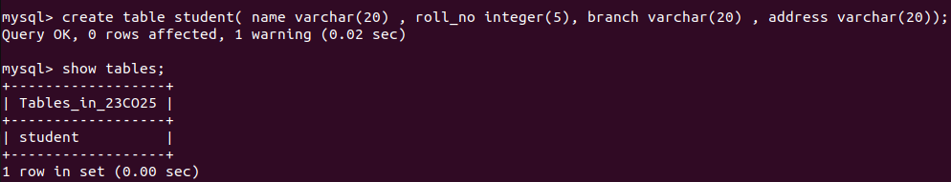

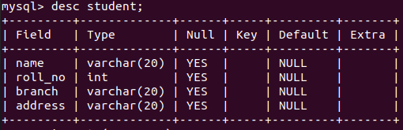

**ALTER TABLE :-**

Alter command is used to:

1. Add a new column.

2. Modify the existing column definition.

3. To include or drop integrity constraints.

Syntax: alter table tablename add/modify (attribute datatype(size));

Example: alter table student add ph_no integer(10);

**Output:**

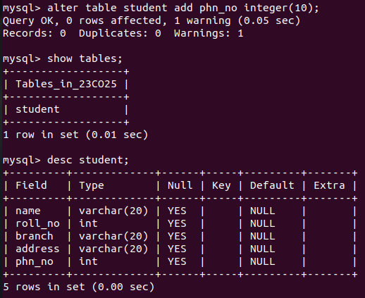

**DROP TABLE :-**

It will delete the table structure provided the table should be empty.

Example: Drop table aman;

**Output:**

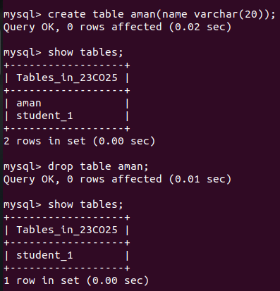

**RENAME TABLE:-**

RENAME old tableName TO newTableName;

Example: RENAME EMPLOYEE1 TO EMPLOYEE2;

**Output:**

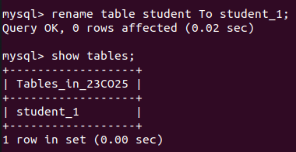

**TRUNCATE TABLE :-**

If there is no further use of records stored in a table and the structure has to be retained then the records alone can be deleted.

Syntax: TRUNCATE TABLE <TABLE NAME>;

Example: Truncate table student;

**Output:**

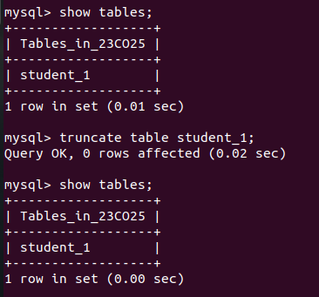

**Procedure:**

1. Open the mysql software tool.
2. Create all the tables related to your own case study
3. Also practice all the other commands of DDL

**Conclusion:**

Hence we have implemented the different DDL commands.